Types of Repeaters
# Source: Chatgpt (GPT‑5 Mini) at [12/18/2025]
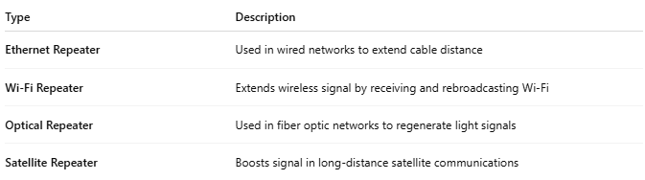
Type | Description
Ethernet Repeater | Used in wired networks to extend cable distance
Wi-Fi Repeater | Extends wireless signal by receiving and rebroadcasting Wi-Fi
Optical Repeater | Used in fiber optic networks to regenerate light signals
Satellite Repeater | Boosts signal in long-distance satellite communications

